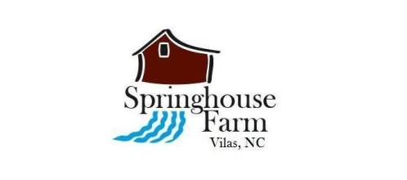
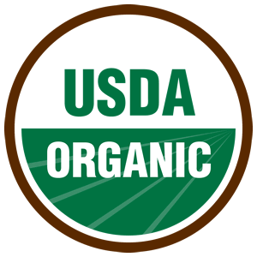 SPRINGHOUSE FARM CSA REGISTRATION 2015

Pick Up Payment
- Enclosed is my payment for a half share ($360)
- Enclosed is my payment for a full share ($510)

- I prefer to pick up my share at Watauga County Farmers Market, Saturday mornings between 8am-11:30am
- I prefer to pick up my share at Springhouse Farm, Tuesday afternoons from 12pm-6pm

Please email registration to:
amyj@skybest.com
Please send payment to:
Springhouse Farm
433 Silverstone Road
Vilas, North Carolina 28692
Contact Information:
Name: _________________________________
Address: ________________________________
Phone: _________________________________
Questions?
Email: amyj@skybest.com
Phone: (828) 719-6825
Email: __________________________________
How did you hear about our CSA? ____________

IMPORTANT: It is the nature of CSAs to help spread out the
risks associated with farming. This means the customer’s payment at the
beginning of the season is nonrefundable. That being said, it is our intention
to overcome all obstacles in growing your food this season and to bring you
value that meets or exceeds what you pay.

